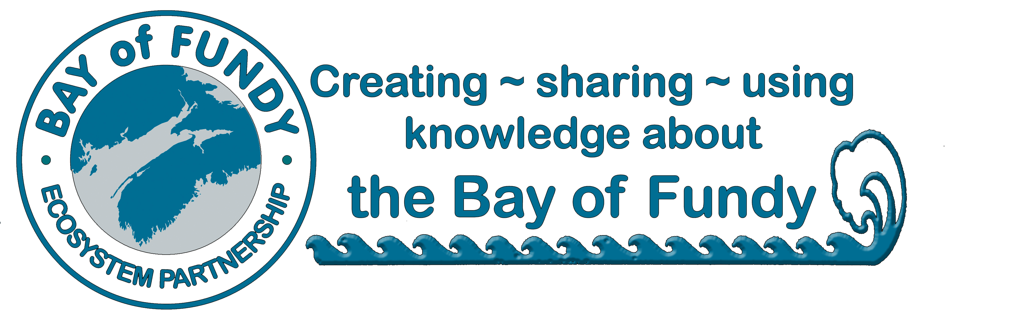**BoFEP**

**Annual Membership Application**

**Joining and Supporting the Bay of Fundy Ecosystem Partnership**

BoFEP is open to all interested citizens and groups who share its vision for protecting, conserving and sustainably using the Bay of Fundy ecosystem. As a non-profit, volunteer organization, we rely upon donations and membership dues from individuals and organizations to operate our core activities and programs. Members are the heart of our organization!

**Benefits of becoming a BoFEP Member include**

* Knowing that you are contributing to the efforts to sustain the Bay of Fundy as a healthy, productive ecosystem, including its adjacent coastal communities!
* Receiving the quarterly electronic newsletter *Fundy Tidings*, which documents new and ongoing activities in and around the Bay.
* Periodic emailing of *Fundy Issues* Fact Sheets and other BoFEP publications
* Opportunities to participate in and contribute to a variety of BoFEP activities, including our biennial workshop/conference and our working groups that address critical issues of concern.
* Opportunities to join the BoFEP Management and Steering Committees
* Participate and vote at the Annual General Meeting

**Membership Categories***(Please check one)*

􀂉 Individual membership ($25)

􀂉 Organizational membership (e.g. non-profit group, government agency) ($100)

􀂉 I wish to make an additional donation to BoFEP of $__________________

**Contact Information**

**Name ______________________________________________________________________________**

**Organization ________________________________________________________________________**

**Mailing address _____________________________________________________________________ Phone _______________________Email ____________________________ Date______________**

**There are three ways to give:**

|  |  |
| --- | --- |
| * Visit [bit.ly/GiveToBayofFundy](https://www.zeffy.com/en-CA/ticketing/bay-of-fundy-ecosystem-partnership-memberships--2025) to give online securely with Zeffy or snap this code |  |
| * Mail your membership form with a cheque (in Canadian dollars) made payble to   **Bay of Fundy Ecosystem Partnership Inc.**  **P.O Box 29011 | Halifax RPO Halifax Shopping Centre**  **Halifax, NS B3L 4T8** | |
| * Send dues via e-transfer to [BayofFundyEP@gmail.com](mailto:BayofFundyEP@gmail.com)   **(please be sure** **to email a copy of this application form to the same address)** | |

Membership dues are for the calendar year. A receipt will be issued as soon as your dues are received. Unfortunately, your contributions are currently not tax deductible.

**Many thanks for your continued support of BoFEP!**