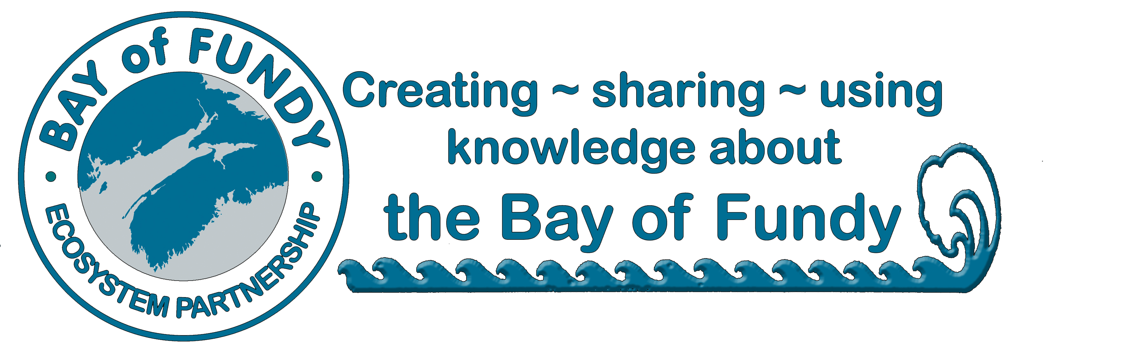
BoFEP
Annual Membership Application

Joining & Supporting the Bay of Fundy Ecosystem Partnership
BoFEP is open to all interested citizens and groups who share its vision for protecting, conserving and sustainably using the Bay of Fundy ecosystem. As a non-profit, volunteer organization, we rely upon donations and membership dues from individuals and organizations to operate our core activities and programs. Members are the heart of our organization. Membership is open to any individual or representative of an organization that supports the purpose of BOFEP.

Benefits of becoming a BoFEP Member:
- Periodic emailing of Fundy Issues Fact Sheets and other BoFEP publications, including the quarterly electronic newsletter “Fundy Tidings.”
- A vote at our Annual General Meeting (organizations are entitled to ONE voting representative)
- Opportunity to join the BoFEP Steering Committee
- Opportunity to join the BoFEP Management Committee
- Knowledge that you are contributing to the efforts to sustain the Bay of Fundy as a healthy, productive ecosystem

Membership Categories (Please check one)

􀂉 Individual membership ($25)

􀂉 Organizational membership (e.g. non-profit group, government agency) ($100)

􀂉 I wish to make an additional donation to BoFEP of $__________________

Contact Information:

Name: ______________________________________________________________________________
Organization: ______________________________________________________
Mailing address: _____________________________________________________________________ ____________________________________________________________________________________
Phone: _______________________Email: ____________________________ Date:______________

Please snail mail your membership form with a cheque (in Canadian dollars) made out to
“Bay of Fundy Ecosystem Partnership Inc.” to the following address:

Bay of Fundy Ecosystem Partnership, PO Box 536, Parrsboro, NS B0M 1S0

Or send dues via e-transfer to bayoffundyep@gmail.com
and be sure to email a copy of this application form to the same address!!!

Membership dues are for the calendar year. A receipt will be issued as soon as your dues are received. Unfortunately, your contributions are currently not tax deductible.
Many thanks for your continued support of BoFEP

