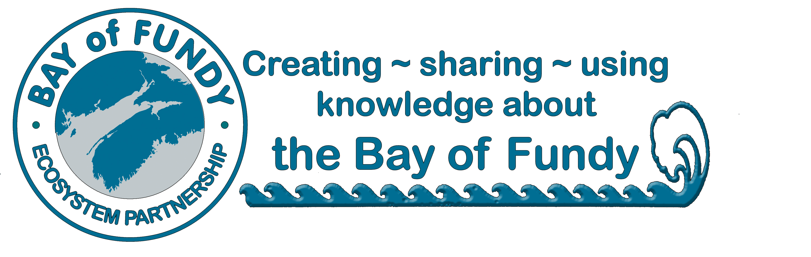
BoFEP
Annual Donor Form

Supporting the Bay of Fundy Ecosystem Partnership
BoFEP’s purpose is to promote the integrity, vitality, biodiversity and productivity of the Bay of Fundy Ecosystem, and the social well-being and economic sustainability of its coastal communities by facilitating communication and co-operation among individuals and organizations interested in understanding, sustainably using and conserving the resources, habitats and ecological processes of the Bay of Fundy. As a non-profit, volunteer organization, we rely upon the generous in-kind and financial support of individuals and organizations to operate our core activities and programs.

We offer a range of donor categories suitable for both individuals and organizations.

Annual Donor Categories (Please check one)

􀂉 The Fundy Society (>$5000) Please specify $____
􀂉 The Tidal Society ($1000-4999) Please specify $____
􀂉 Fellow ($250-500)
􀂉 Patron ($100-250)
􀂉 Associate ($25-100)
􀂉 Other, please specify $__________

􀂉 I wish to become a BoFEP member (requires a minimum donation of $25). Please see the BoFEP website for benefits.

Date (dd/mm/yyyy): _________________________________

Contact Information:

Name: ______________________________________________________________________________
Organization (if any):______________________________________________________
Mailing address: _____________________________________________________________________ ____________________________________________________________________________________
Phone: _______________________Fax: ______________________Email: ______________________

Please mail your membership form with a cheque (in Canadian dollars) made out to
“Bay of Fundy Ecosystem Partnership Inc.” to the following address:

Bay of Fundy Ecosystem Partnership
PO Box 536, Parrsboro, NS B0M 1S0
􀂉 BoFEP would like to publicly acknowledge your gift, but you may check here to remain anonymous.

Donations are for the current calendar year. A receipt will be issued as soon as your gift is received. We are currently working towards gaining charitable status. Until such time, your donation is not tax deductible.

Many thanks for your continued support of BoFEP

