One hundred years of monitoring in the
St. Croix Estuary

One hundred years of monitoring in the St. Croix Estuary provides insight into the decade to decade changes in sea surface temperature and surface salinity, helping researchers to better understand the timing of these seasonal cycles and how this might affect the dozens of plankton species inhabiting the area.

A research project to review the 100 years of monitoring has recently been completed by the Bay of Fundy Ecosystem Partnership with funding from Environment Canada and in-kind support from DFO and the St. Croix Schoodic Band of the Passamaquoddy Nation. “The aim of the project was to improve our understanding of the diversity, concentration and phenology of plankton populations in St. Croix Estuary,” explains Marianne Janowicz, Chairperson of the Bay of Fundy Ecosystem Partnership (BoFEP).

The project reveals salinity is most variable during the months of April and May, corresponding to the spring runoff in which excess fresh water pours into the bay. Plankton diversity is greatest during the month of September, when surface salinity is both highest and least variable. And while biological diversity and concentration varies over the sampling period, the data shows herring and winter flounder appear to be more abundant now than they were in the past.

Since 1916, data has been collected from the Prince 6 monitoring station using a variety of methods, from weather observations and basic thermometers to plankton tows and sophisticated temperature and depth recorders. Biological data was collected via vertical and horizontal tows, using both a coarse and fine mesh net. The biological samples were then rinsed, separated and examined under a microscope. Variables included sea surface temperature, surface salinity, water colour, air temperature and plankton concentration.

While instruments such as the Seabird® 25 CTD profiler provide more precise measurements, the methods employed in the past remain sound, and thus the data still provides a reliable timeframe of surface temperature, surface salinity and biological change.

Temperature Data

In 1961, Legaré reported the following observations based on the surface temperature data collected previously: “At Prince 6 the surface layer has its maximum temperature a month earlier than at the bottom, and the minimum temperatures are reached around mid February at both depths. The water becomes uniform from bottom to surface in March and October.”

Since the surface temperature measurements were collected monthly for the majority of the study, one can derive only general observations from the data. For example, between the years 1935 and 1944, there were eight temperature maxima of 14℃ or higher, as indicated in Figure 7. Between 1955 and 1964, there were only three temperature maxima in this range, however it is difficult to say whether this was indicative of a cooling period as the 1955-1964 decade was also one of only two in which the winter minimum did not drop below zero degrees.

And while winter lows have on average been higher this past decade compared with the temperatures recorded during 1915-1925, F.J. Fife, coauthor of the report “A century of monitoring station Prince 6 in the St. Croix River estuary of Passamaquoddy Bay”, notes that the winter lows have been decreasing since 2012. Going forward, more frequent surface temperature monitoring would enable researchers to draw more precise conclusions from the data.

Figure 7: One hundred year time series of sea surface temperature at station Prince 6. There are data gaps resulting from a fire at the Atlantic Biological Station in 1931 and from lack of winter sampling between 1941 and 1945. Sampling rate was weekly from 1916 to 1944 and monthly thereafter.

Salinity Data

The timing of freshwater input into the estuary is derived from surface salinity measurements. And while the data shows several marked decreases in salinity (during the years 1983, 1989 and 2014 for example), it is important to keep in mind that these measurements were collected monthly for most of the sampling period, and so it is hard to make any sweeping statements about the highs and lows illustrated in the salinity graph. It is also normal for salinity to decrease over the course of a tidal cycle, during a spring melt or when a large storm passes over the drainage basin of the estuary. As this process can affect the diversity and abundance of the species living there, more frequent surface salinity monitoring would also be beneficial.
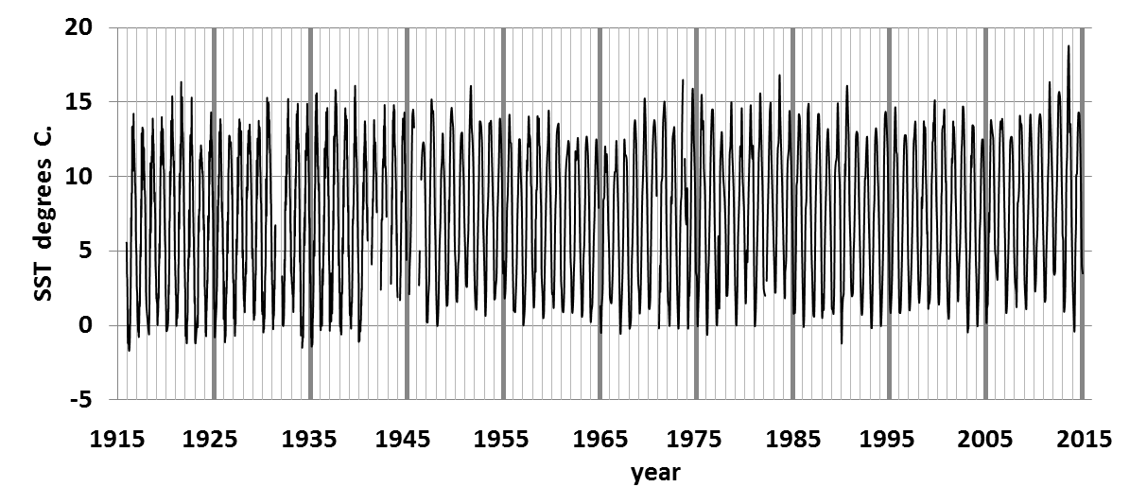

Figure 9: Time series of sea surface salinity at station Prince 6. There are large data gaps resulting in part from a fire at the Atlantic Biological Station in 1931 and possibly the lack of suitable lab equipment. Winter observations are lacking between 1941 and 1945. Sampling rate was weekly from 1916 to 1944 and monthly thereafter.

Biological Data

The BoFEP project reveals some interesting shifts in biological diversity. For example, data collected from the vertical plankton tows between the years 2011-2014 show the density of setal feeders has increased. These organisms use feeding appendages called setae to catch the food particles flowing past them. Calanoid Copepoda (a small setal feeder) increased to a peak density of 11,000 per cubic meter in 2014, while the density of Euphausiidae (another small setal feeder, similar to a shrimp) and water fleas also increased.

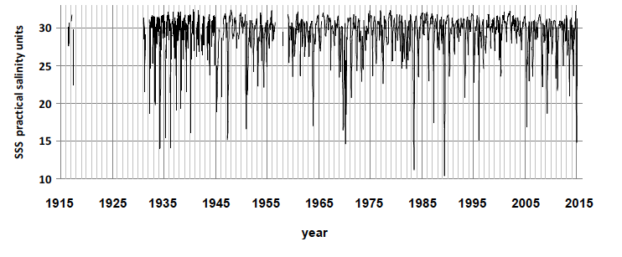
Both Calanoid Copepoda and the water fleas reached their maximum density between the months of July and August. This appears to be a general trend, with mucous feeders (such as sea snails and tunicates) also reaching a peak density of 1,000 per cubic metre during that same time period.

There is some difference between the catch data collected using the fine mesh vertical tows verses the fine mesh subsurface tows. For example, the latter reveals Calanoid Copepoda density to be even greater than the previous estimate, with a high of 50,000 per cubic meter in August 2014. Density then dropped to 11 per cubic meter later in the year. Although this was a record low, the drop itself is not unusual as Figure 74 shows Copepoda density spikes again each summer.
Figure 74: Calanoid Copepoda density (number per cubic meter) as estimated from fine mesh subsurface plankton tows.

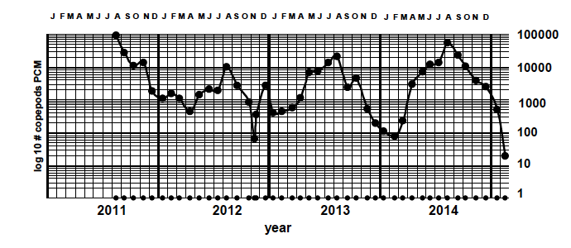
The density of bivalve (hinged-shell organisms such as a clam), polychaete (a type of worm) and barnacle larvae has also increased gradually over the past four years, with an average of 1,000 per cubic metre as indicated by the fine mesh vertical tows. However echinoderm larvae (such as starfish) have become less common, with no catches reported in 2014.

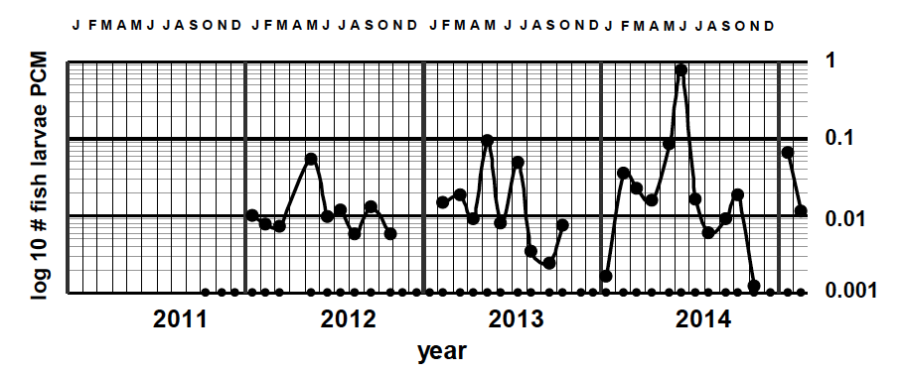

The fine mesh vertical tow data indicates fish egg density is fairly small, with only 7 catches in 2014. However this number has increased slightly since 2011. The coarse mesh subsurface tows indicate that fish eggs are common over a longer period of time, increasing from five months in 2013 to six months in 2014. This same set of data shows the density of fish larvae has also increased slightly since 2011, peaking between the months of May and June.

Figure 132: Larval fish density (number per cubic meter) as estimated from coarse mesh subsurface plankton tow. Sampling dates are marked along the bottom of the plot.

Biological Data

As previously stated, herring and winter flounder larvae appear more abundant now than they were in the past, with herring appearing in the late summer and fall, and winter flounder appearing in the spring, summer and fall. Seasnail larvae and Ctenophores (such as the comb jelly) are also more common, with the density of Ctenophores increasing by 75% since 2011.

Sandlance larvae are present in small numbers, an interesting find considering there are commercial fisheries for this species in other parts of the world. Longhorn sculpin larvae were also present in the coarse mesh subsurface tows between 2012 and 2014. Historical records show this species first appeared in the plankton tows in 1968. Apart from one occurrence in 1969, longhorn sculpin were not recorded in the estuary again until 2012. Other species such as the lumpfish, alligatorfish and three spine stickleback were recorded only once in recent years.

The project involved analysing samples from approximately 1830 tows that took place between 1916 and 2014 at the Prince 6 monitoring station. “Time-series studies of this magnitude are rare,” explains F.J. Fife, R.L.M. Goreham and F.H. Page, authors of the report. “Yet they are crucial to identification of long-term ecological trends and regime shifts as well as to the development of adaptive management strategies.”

Works Cited

F. J. Fife, R. L. M. Goreham and F. H. Page. 2015. A century of monitoring station Prince 6 in the St. Croix River estuary of Passamaquoddy Bay.

Legaré, J.E.H. 1961. The Zooplankton of the Passamaquoddy Region. Fish. Res. Bd. Canada Manuscript report series (biological) no. 707: 37.

Vachon, A. 1918. Hydrography in Passamaquoddy Bay and Vicinity. Biological Board of Canada. Sessional paper no. 38a: 295-328.

