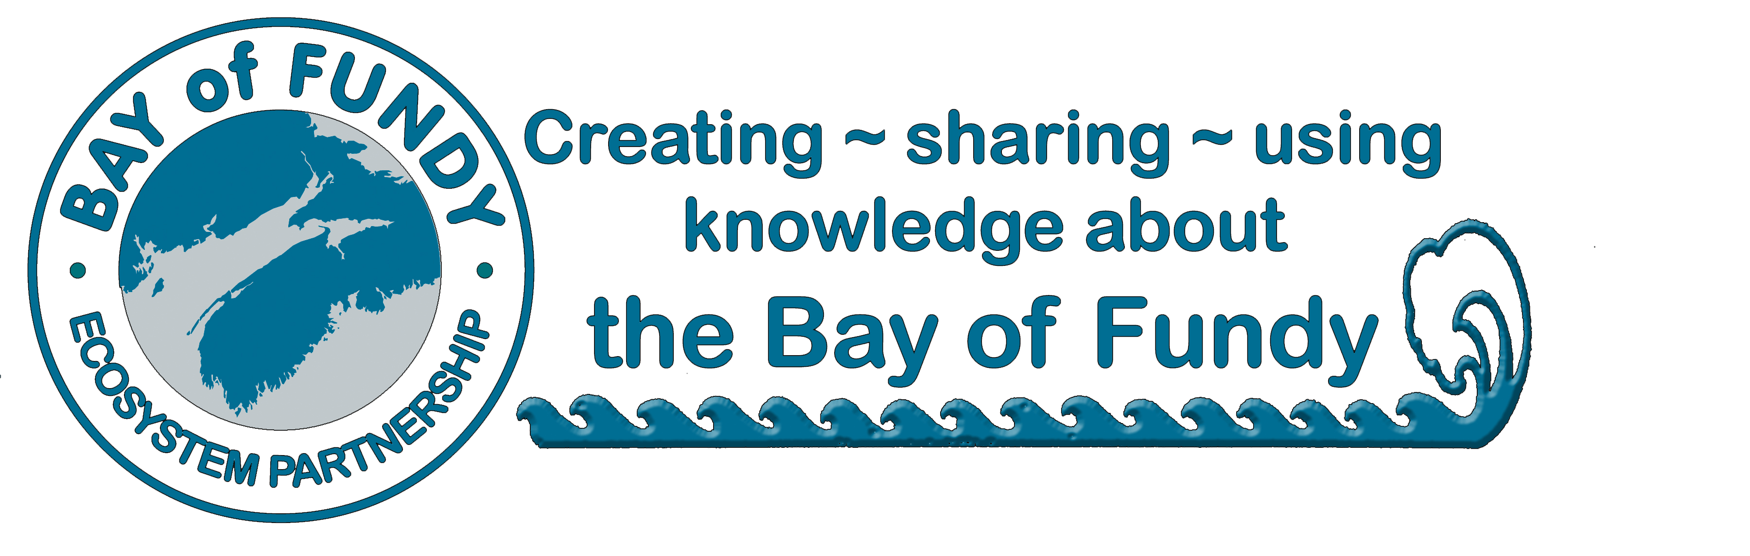
BoFEP
Annual Donors 2013

Belonging to and Supporting the Bay of Fundy Ecosystem Partnership
BoFEP is a widely dispersed "Virtual Institute" open to all interested citizens and groups who share its vision for protecting, conserving and sustainably using the Bay of Fundy ecosystem. As a non-profit, volunteer organization, we rely upon the generous in-kind and financial support of individuals and organizations to operate our core activities and programs.

We offer a range of donor categories suitable for both individuals and organizations.

Annual Donor Categories (Please check one)

􀂉 The Fundy Society (>$5000) Please specify $____
􀂉 The Tidal Society ($1000-4999) Please specify $____
􀂉 Fellow ($500)
􀂉 Patron ($250)
􀂉 Sustaining Associate ($100)
􀂉 Contributing Associate ($25)
􀂉 Student ($10)
􀂉 Other, please specify $__________

Donors may indicate the preferred use of their contributions:
􀂉 Where it is needed the most
􀂉 Operations and Secretariat
􀂉 Communications products
􀂉 Student Support
􀂉 BoFEP Biennial Bay of Fundy Workshops
􀂉 BoFEP Working Groups (specify which group if desired) ________________________

Contact Information:

Name: ______________________________________________________________________________
Affiliation (if any): ____________________________________________________________________
Mailing address: _____________________________________________________________________ ____________________________________________________________________________________
Phone: _______________________Fax: ______________________Email: ______________________

Please mail your membership form with a cheque (in Canadian dollars) made out to
“Bay of Fundy Ecosystem Partnership Inc.” to the following address:

BoFEP Secretariat, Acadia Centre for Estuarine Research, P.O. Box 115,
23 Westwood Avenue, Acadia University, Wolfville, NS, B4P 2R6, Canada.

􀂉 BoFEP would like to publicly acknowledge your gift, but you may check here to remain anonymous.

Donations are for the current calendar year. A receipt will be issued as soon as your gift is received.

Many thanks for your continued support of BoFEP

